Line of Best Fit Using Graphing Calculator
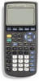 | The directions on this page were prepared using the TI-83+ graphing calculator.

Is there a relationship between the fat grams
and the total calories in fast food?

  Sandwich | Total Fat (g) | Total Calories
  Hamburger | 9 | 260
  Cheeseburger | 13 | 320
  Quarter Pounder | 21 | 420
  Quarter Pounder with Cheese | 30 | 530
  Big Mac | 31 | 560
  Arch Sandwich Special | 31 | 550
  Arch Special with Bacon | 34 | 590
  Crispy Chicken | 25 | 500
  Fish Fillet | 28 | 560
  Grilled Chicken | 20 | 440
  Grilled Chicken Light | 5 | 300

Can we predict the number of total calories based upon the total fat grams?
1. Enter the data in the calculator lists. Place the data in L₁ and L₂.  STAT, #1Edit, type values into the lists | 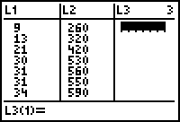
2. Prepare a scatter plot of the data.  Set up for the scatterplot.  2nd StatPlot - choices shown at right.  Choose ZOOM #9 ZoomStat. Graph shown below.  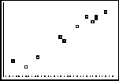 | 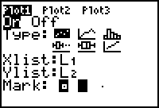
3. Have the calculator determine the line of best fit.  STAT → CALC #4 LinReg(ax+b)  Include the parameters L₁, L₂, Y₁.  (Y₁ comes from VARS → YVARS, #Function, Y₁)  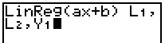  You now have the values of a and b needed to write the equation of the line of best fit. See values at the right.  y = 11.73128088x + 193.8521475 | 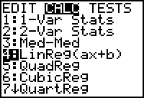  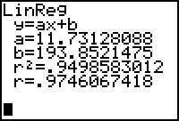
4. Graph the line of best fit.  Simply hit GRAPH.  To get a predicted value within the window, hit TRACE, up arrow, and type the desired value.  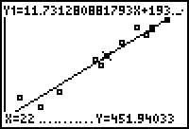 | 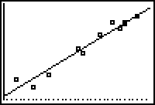  Question: Predict the total calories based upon 22 grams of fat.  ANS: 451.940 calories

